Full paper template for the 14th International Symposium on Fiber-Reinforced Polymer Reinforcement for Concrete Structures at Queens University Belfast, FRPRCS-14 2019

Robinson, D.¹, Taylor, S.E.¹, Uddin N.², O Brien E.J. ³,

¹ Intelligent Infrastructure Group, School of Planning, Architecture, and Civil Engineering, David Keir Building, Queen's University Belfast, Northern Ireland
² Department of Civil, Construction and Environmental Engineering, University of Alabama at Birmingham, USA
³ School of Civil, Structural & Environmental Engineering, University College Dublin, Dublin 4, Ireland

Abstract
The maximum number of words should be limited to 180. The abstract should be specific and contain the major findings of the paper.

Keywords: Maximum 7 keywords

Corresponding author’s email: frprcs-14@qub.ac.uk

General Information

If you use this document as a master file for your paper, your paper should conform to the editorial guidelines formulated below.

General Setup

All pages should be adjusted to A4 size (29.7 cm height and 21 cm breadth). The margins should be 2.5 cm on all sides. Use Arial font. The paper should not exceed 4 pages including figures, tables, and references.

Title, Authors, Affiliation

The title should be in Arial 14, bold, left-aligned, ragged, and limited to 120 characters. Leave one blank line between title and authors. List up all authors use full names or abbreviations for the surname. The authors should be in Arial 11, left-aligned, ragged. Another line should be left free between authors and affiliations. Use italics for affiliations, Arial 11, left-aligned, ragged.
The abstract should be in Arial 11, left-aligned, ragged.
Leave four blank lines between affiliations and abstract, two blank lines between abstract and keywords and another four between keywords and main author’s email address.
For keywords, write keywords followed by a colon in Arial 11, bold, left-aligned, ragged. Add a maximum of 7 keywords in Arial 11, left-aligned, ragged.
Leave the remaining page free and start with the paper text on the next page.

Standard Text

Use Arial 11, single spacing, and forced alignment for standard text without indenting. Leave a blank line between the final text passage of a section and the following heading or subheading. Do not leave a line between two sections within the same subheading.

Headings and Subheadings

Use Arial 14 bold letters for main headings and leave one blank line between heading and text.

Subheadings
Use Arial 11 bold letters for subheadings. Do not leave a blank line between subheadings and text.

Second level headings
Avoid using two many sublevel headings. If necessary, use Arial 11 standard and underline the sublevel heading.

Equations

Formulas and equations should be separated from the text by blank line before and after. In case a number of equations are used, provide numbering.

τ = η · g;˙ (1)

τ = τ₀ + η · g;˙ (2)

τ = τ₀ + κ · g;˙^{n} (3)

Where:
τ = Shear stress [Pa]
τ₀ = Yield stress [Pa]
η = Viscosity/Plastic viscosity [Pa·s]
g;˙ = Shear rate [1/s]
κ = Flow consistency index [[Pa·s^{n}]
n = Flow behaviour index [-]

Figures and Tables

General aspects
Figures and Tables can be placed within the text or at the end of the text behind the references list. It is, however, recommended to place them close to the text, which refers to them. Figures and tables should be treated in the same way.

Figures
Figures should be centre justified. Leave two blank lines between the text and the figure unless the figure does not appear right at the right top of the page. In case the figure appears right on top, do not leave a blank line. Leave one blank line between figure and figure caption.

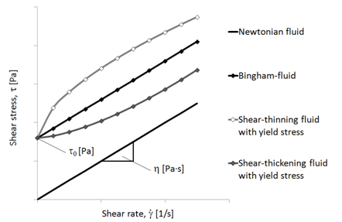

Figure 1: This is an example figure
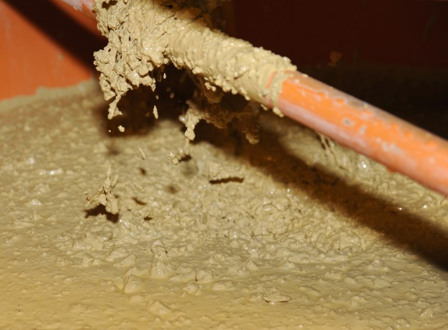

Figure 2: This is an example figure

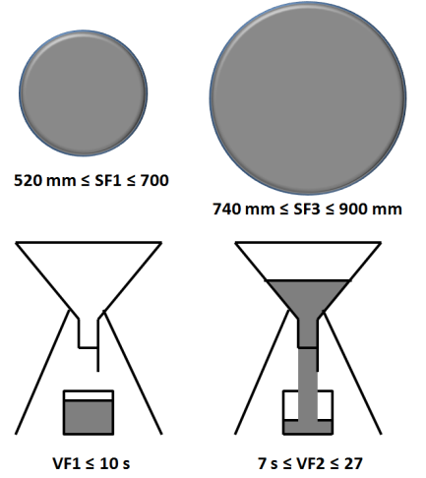

Figure 3: This is an example figure

Leave two blank lines between figure description and next text passage or heading. Leave only one or two blank lines between two consecutive figures or figures and tables depending upon legibility. Refer to all figures in the text.

Tables
Tables should be centre justified. Table descriptions should be on top of the table with one blank line distance to the text. Another single blank line should be left between table and table description.

Table 1: Example table

Concrete type | Powder content [kg/m³] | Water powder ratio
Concrete A | 500 | 0.3
Concrete B | 575 | 0.4
Concrete C | 625 | 0.45

Table 2: Example table

Concrete type | Powder content [kg/m³] | Water powder ratio (%)
Concrete A | 500 | 0.3
Concrete B | 575 | 0.4
Concrete C | 625 | 0.45

Leave two blank lines below each table. A single line may be left between two tables if this improves the layout. All tables should be consistent in style. Examples are given above.

Citations

Consecutive numbers are preferred (e.g. [1] and [2, 3]). Each reference shall be listed in a reference section as given in the example below.

References

[1] Schmidt, W., 2011, "Challenges of the African Environmental Conditions for Concrete Mixture Composition," Workshop Cement and Concrete for Africa, Berlin, Germany, pp. 37-49.
[2] Schmidt, W., Brouwers, H. J. H., Kühne, H.-C., and Meng, B., 2010, "Effects of Superplasticizer and Viscosity-Modifying Agent on Fresh Concrete Performance of SCC at Varied Ambient Temperatures," Design, Production and Placement of Self-Consolidating Concrete - Proceedings of SCC2010, Montreal, Canada, September 26-29, 2010, K. H. Khayat, and D. Feys, eds., Springer, pp. 65-77.
[3] Schmidt, W., Kühne, H. C., Uzoegbo, H. C., and Msinjili, N. S., 2011, "Building practice and Concrete Infrastructure Development in Eastern and Southern Africa," Concrete Plant International, 2011(3), pp. 32-37.

